Sweet and Sour Chicken

Ingredients (Per Pair)
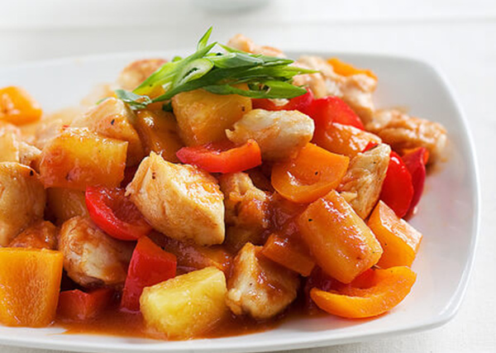
200g chicken thigh fillet
1 Tbs beaten egg
Pinch of salt
1 tsp cornflour
2 Tbs tomato sauce
2 Tbs white vinegar
2 Tbs pineapple juice
1 tsp light soy sauce
2 Tbs brown sugar
¼ red capsicum, chopped
¼ green capsicum, chopped
¼ onion, chopped
½ carrot, sliced thin
2 slices pineapple rings, cut to 4-6 pieces
½ tsp crushed ginger
1 Tbs oil

Method
- Cut chicken thigh fillet in chunks.
- Marinate chicken: In a bowl, stir and coat the chicken with the beaten egg, salt and cornflour. Set aside.
- Make sweet and sour sauce: Whisk together the pineapple juice, vinegar, tomato sauce, light soy sauce, and brown sugar with a fork.
- Heat frying pan over medium high heat. Add oil and fry onion and chicken until brown and cooked through.
- Turn the heat to medium and add ginger, carrot, capsicums and pineapple pieces. Fry for another minute.
- Add sweet and sour sauce and cook until thickens.
- Taste the sauce and add more brown sugar if you’d like.
- Serve hot with steamed rice.

Learning Intention

To know how sweet and sour ingredients can be adapted to change the flavour or a dish.

- Why is it important to use the blue chopping board for raw chicken?
- What ingredients make the sweet and what creates the sour components?
- What was something you could improve today? How would you do that?

