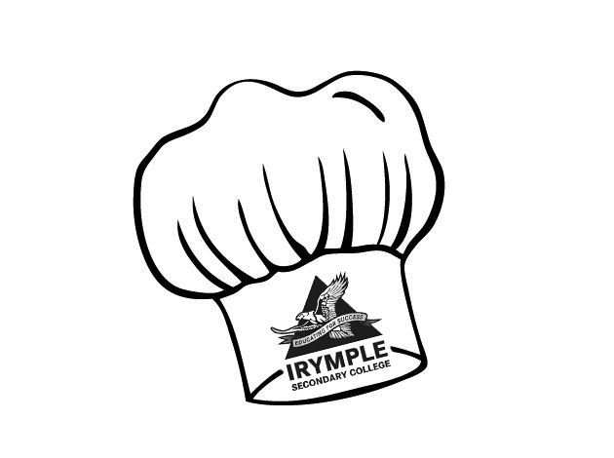

Corn Fritters

Ingredients (Per Pair)
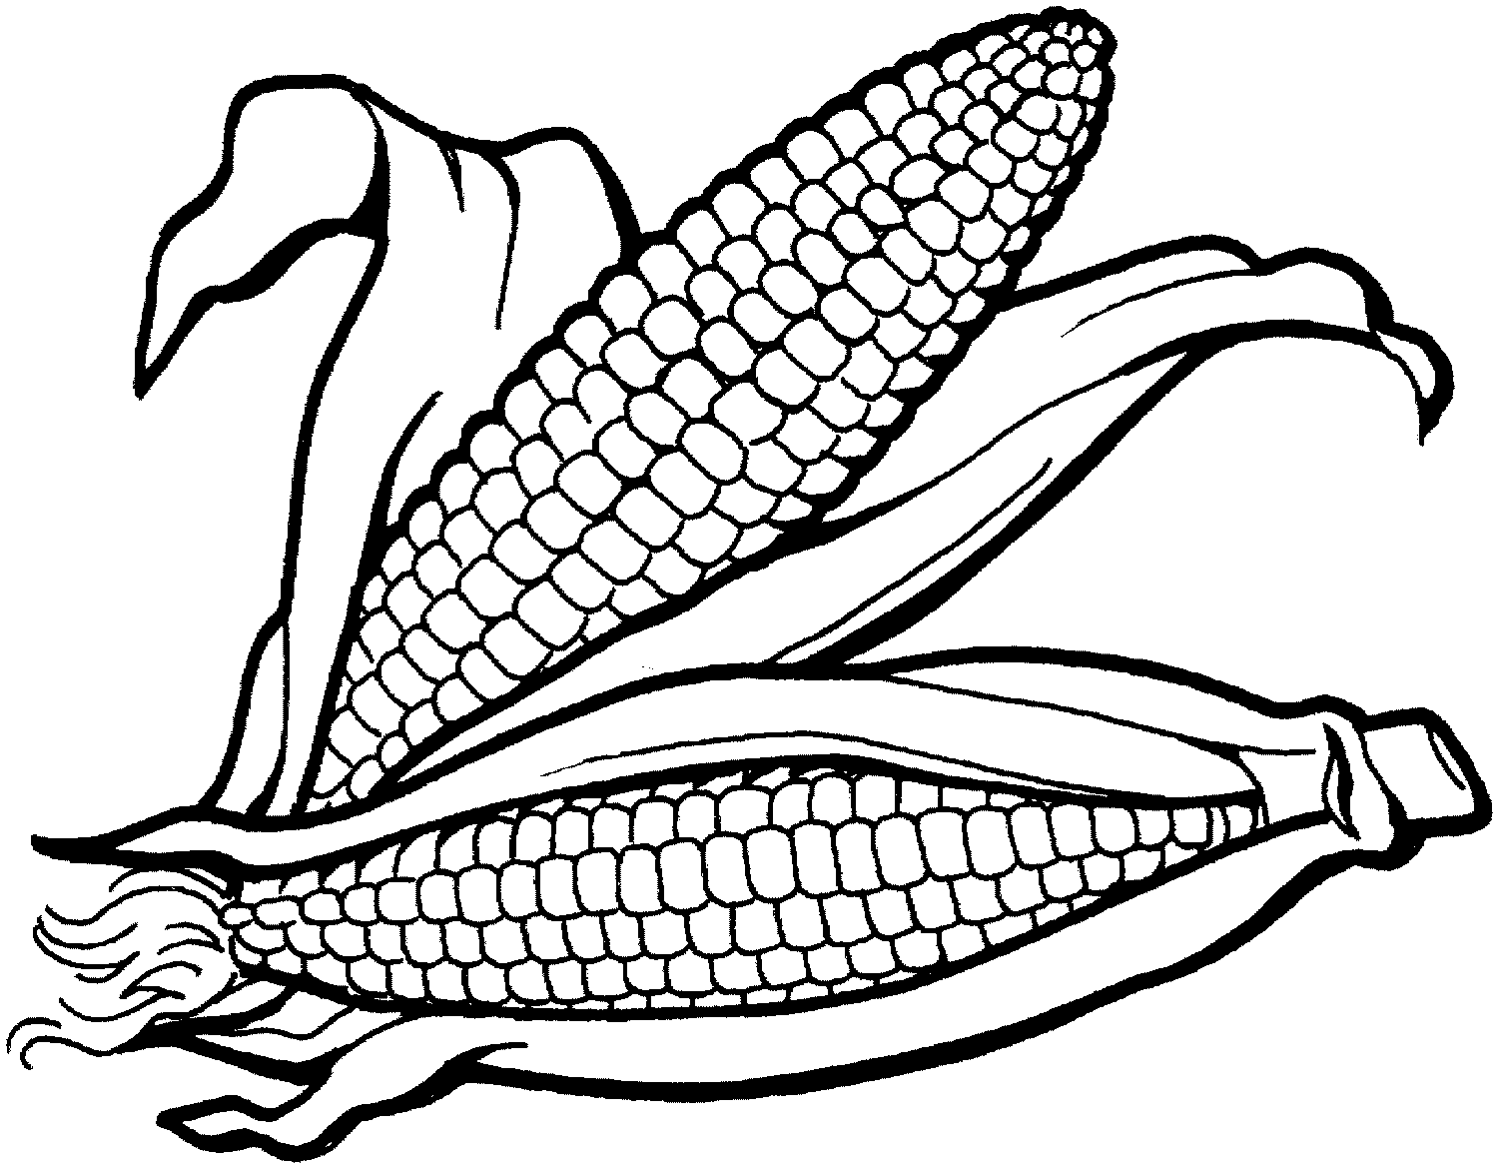
½ tin corn kernels (include juice)
½ rasher bacon
½ cup cauliflower
1 spring onion
1 egg
½ cup SR flour.
¼ cup milk
Pepper
Oil for frying

Method:

- Place flour into a bowl.
- Cut bacon into small pieces and cook well in a frying pan.
- Drain bacon on paper towel to remove excess oil.
- Beat the egg.
- Add the corn, juice, milk and beaten egg to the flour and mix well.
- Break the cauliflower into small florets, chop finely and add to the mixture.
- Cut the spring onion into small pieces and add to the mixture.
- Add cooked bacon and the pepper to the mixture.
- Mix well.
- Heat oil in the frying pan over medium heat.
- Cook a tablespoonful for each fritter and turn over when golden.
- When fritters are golden on both sides, place on paper towel to drain and keep warm.
- Serve with tomato or BBQ sauce.

Learning Intention
To learn how to cut vegetables finely to incorporate through a recipe.

- Why is paper towel used in this recipe?
- Why is it so important to place a damp dish cloth under the chopping boards?
- Explain why you shouldn’t make fritters too large and thick?

