Gingerbread House

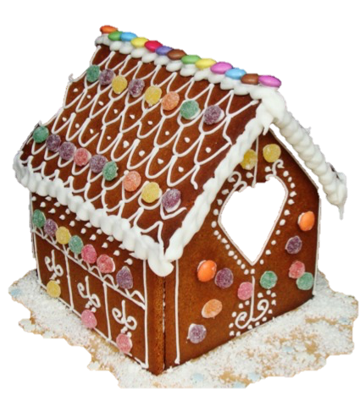
Ingredients (Per Student)

½ cup margarine
2/3 cup brown sugar
1 egg, beaten
3 Tbs golden syrup
2½ cup plain flour
½ tsp ground ginger
1 tsp cinnamon
½ tsp bicarbonate soda

Method

- Preheat oven to 180$℃$.
- Cream the margarine and sugar in bowl.
- Add the egg gradually, then the golden syrup.
- Sift flour, ginger, cinnamon and bicarbonate soda together and add to the creamed mixture.
- Form a dough and knead lightly until smooth. Add more flour if too sticky.
- Roll out the dough and cut into shapes according to the stencils. If rolled out thinly, a crisp texture will result and if rolled out thickly, a softer texture will result.
- Bake shapes for 10 – 20 minutes. Time will vary according to size, shape and thickness.
- Cool and decorate as required with Royal icing and lollies.

Learning Intention
To learn why plain flour is used when making gingerbread.

- Why do we use plain flour in gingerbread?
- How is dried ginger, grown and made?
- Explain something that you did well today and why.

