Choc-Orange Self-Saucing Pudding

Ingredients (Per Pair)
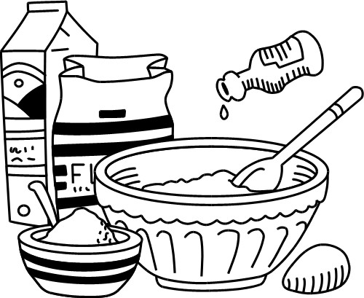
1½ Tbs margarine
¼ cup sugar
½ cup SR flour, sifted
2 Tbs orange juice
1 orange, zested
½ egg
1 Tbs cocoa
½ tsp vanilla

Sauce
¼ cup sugar
2 tsp cocoa
½ cup hot water

Method
- Preheat oven to 180$℃$ and grease a medium, deep baking dish.
- Sift flour and cocoa powder together.
- Batter: Cream margarine and sugar in a mixing bowl.
- Add orange zest, vanilla and egg and mix well.
- Stir in sifted flour and cocoa alternately with the orange juice.
- Place batter evenly in the greased baking dish.
- Mix extra sugar and cocoa in a small bowl to remove lumps.
- Sprinkle the extra sugar and cocoa over the top of batter.
- Pour the hot water in gently over the back of a wooden spoon.
- Bake pudding for 15-20 minutes.
- Serve with ice-cream.

Learning Intention
Today we will learn which 2 ingredients make jaffa and how it can be used in other dishes.

- Describe the creaming process.
- Why is a wooden spoon used when pouring the sauce over the batter?
- Identify something that you feel went well today. Explain why.

