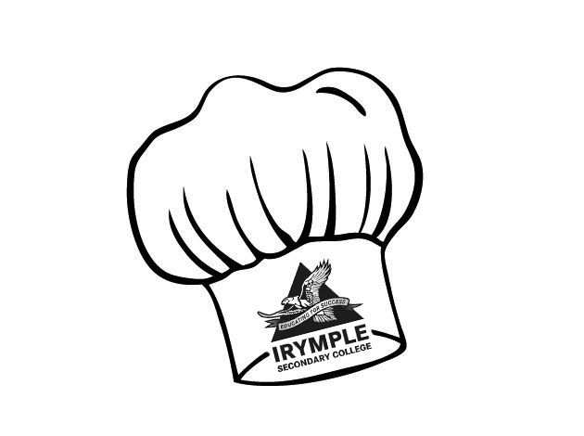
Lamb Koftas

Lamb Koftas Ingredients (Per pair)

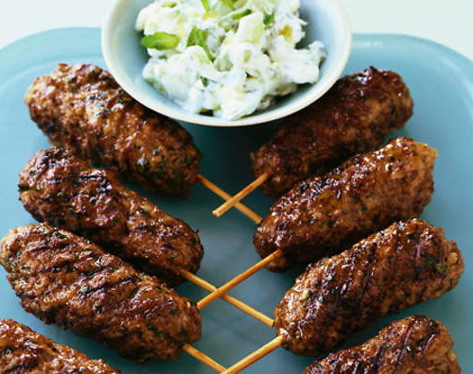
250g lamb mince
½ tsp minced garlic
1/8 tsp ground all spice
1/8 tsp ground cardamom
1/8 tsp cayenne pepper
1/8 tsp ground ginger
½ tsp ground cumin
½ tsp ground coriander
¼ tsp ground paprika
¼ tsp salt
a few shakes of pepper
½ small onion, grated finely
1 sprig continental parsley, chopped
2 Tbs oil for frying

Method
- Mix the lamb, herbs and spices in a bowl and season with salt and pepper.
- Shape ¼ cup lamb mixture at a time into four 8 cm-long sausages. Thread 1 sausage onto each skewer. (Refrigerate for 20 minutes or until firm)
- Add oil to a large frying pan on medium heat. Cook koftas, turning occasionally, for 10 minutes or until cooked through.
- Transfer to a large serving plate, cover with foil. Rest for 5 minutes.
- Serve hot with tzatziki sauce.

Learning Intention
To understand more about the spices in a Greek cooking
- What is all spice a mixture of?
- Other than all spice, research and explain what the plants of the other spices look like
- Why do we let the koftas rest before cooking them?

