Chop Suey

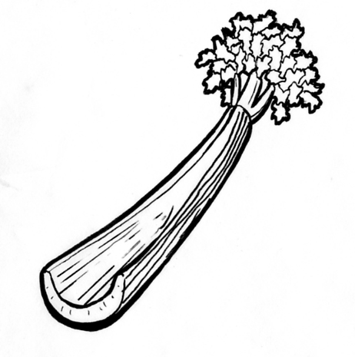
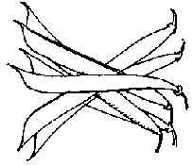
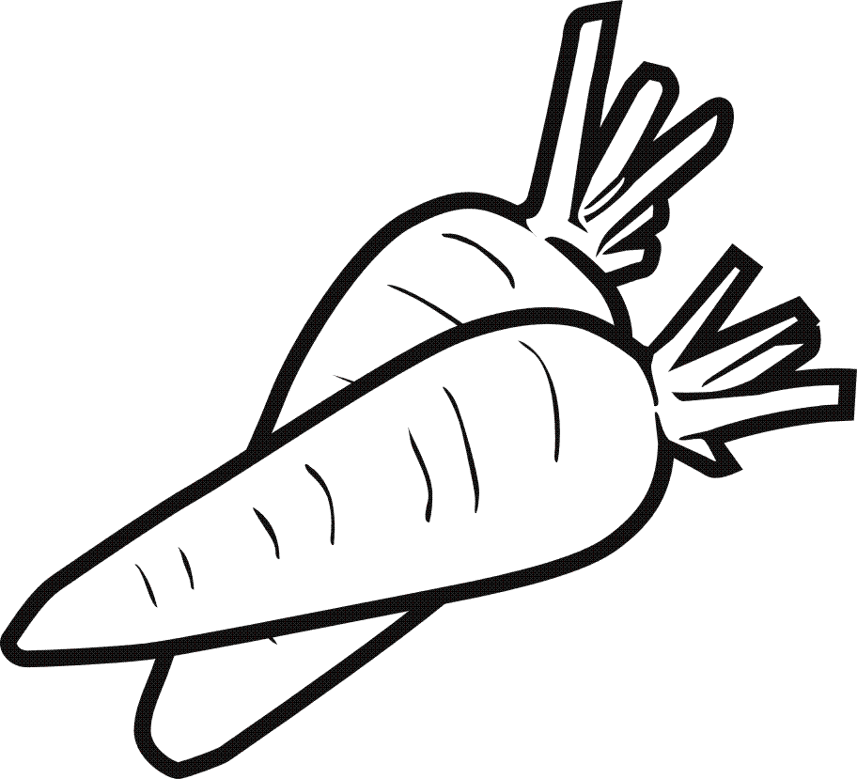
Ingredients (Serve 2)
100g Minced Beef
1Tbs long grain rice
1/3 stick celery
¼ onion
6 French beans
½ carrot
1/8 cabbage
¾ tsp chicken stock powder
1tsp curry powder
1 Tbs oil for frying
¾ cup hot water
Method
- Collect ingredients.
Dice onion, and celery, shred cabbage, peel and grate carrot.
- Top ‘n’ tailed and chop French beans.
- Dissolve chicken stock powder in ¾ cup of hot water.
- In a large saucepan, add oil and fry onion for 2 minutes.
- Add minced beef, sprinkle curry powder over meat and fry until meat is well browned.
- Add chopped beans and celery.
- Add rice and stir well.
- Add shredded cabbage, grated carrot, and chicken stock.
- Cover and cook over low heat for about 10 minutes.
- Dish up on a plate and serve hot.
Learning Intention
To learn how to make a one pot, nutritious meal.
- List the vegetable preparation techniques and name 2 other foods that can be prepared the same way for each.
- Why is Chop Suey classed as a nutritious meal?
- What are two main ingredients? What could be used instead of each and why?

