Sponge Cake

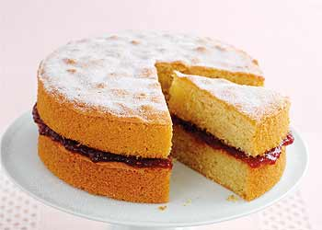
Ingredients (Per Pair)

3 eggs
¾ cup sugar
1cup SR flour
2 Tbs water
2 tsp vanilla
3 Tbs strawberry jam
Icing sugar to dust

Method

- Preheat oven to 180°C.
- Line 2 round baking tins with baking paper.
- Sieve flour twice in a medium mixing bowl.
- Separate eggs, egg white in a big mixing bowl and egg yolk in a small one.
- Beat egg whites with electric beater (on high) until stiff peaks form. Gradually add sugar and beat until thick and glossy. Do not over-beat.
- Add egg yolks, one at a time, beating well after each addition.
- Add vanilla. Beat to combine.
- Gently fold in sifted flour and then fold in water.
- Divide mixture evenly between 2 lined round tins.
- Bake for 12-15 minutes or until cake springs back when touched.
- Remove cakes from tins and cool on a wire rack.
- Place jam in a 1cup measuring cup and stir to soften.
- When cool, spread one sponge cake with jam and place the other sponge on top.
- Dust with icing sugar.
Learning Intention
To know how to make and maintain the aeration when making a sponge.
- Identify the 2 ways that aeration is created with a sponge? Explain how.
- What is done to maintain the fluffiness of the mixture?
- If time wasn’t limited, how would you like to decorate your sponge?

