Italian meat ball soup

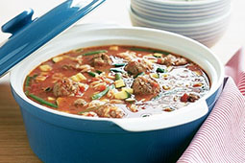
Ingredients (Per Pair)
Meat balls
200g beef minced
¼ red onion, grated
1 tsp crushed garlic
¼ cup breadcrumbs
a few basil leaves, finely chopped
1 Tbs parmesan cheese
½ egg, lightly beaten

Method

- Combine mince, onion, garlic, breadcrumbs, basil, parmesan and egg in a large bowl.
- Season with salt and pepper. Mix well.
- Roll tablespoonfuls of mixture into balls. Place on a plate.

Ingredients
Soup
1 tsp beef stock powder
2 cups hot water
½ can diced tomato
½ tsp Italian seasoning
¼ cup macaroni
½ cup frozen mixed vegetables
½ Tbs shredded parmesan cheese

Method
- Combine beef stock powder and hot water in a saucepan. Add undrained tomatoes and Italian seasoning, bring to boiling.
- Add meatballs, pasta and frozen vegetables.
- Return to boiling, reduce heat.
- Simmer covered for about 10 minutes or until pasta is tender.
- Ladle soup into bowls and sprinkle with cheese.
- Serve hot.
Learning Intention
To know how to make a wholesome, delicious soup.
- Explain why this dish is so nutritious.
- How can you and your partner maximise your time efficiency when making this dish?
- Describe how you think this dish is a convenient way of cooking a meal.

