Cornish Pasties

Ingredients (per pair)
(Makes 8)
½ Tbs oil
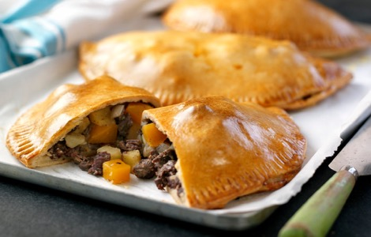
½ small onion, finely chopped
½ tsp minced garlic
150g beef mince
½ small potato, peeled, finely chopped
½ carrot, peeled, finely chopped
1 tsp cornflour
¼ tsp beef stock powder
50ml hot water to make stock
1 tsp Worcestershire sauce
1 tsp tomato sauce
2 sheets shortcrust pastry
½ egg, lightly beaten

Method

- Preheat oven to 200°C.
- Heat oil in a frying pan over medium heat. Add onion. Cook, stirring, for 2 minutes or until soft.
- Increase heat to high, add garlic and mince. Cook, stirring, for 2 to 3 minutes or until browned.
- Add potato and carrot. Cook for 3 minutes or until vegetables are just tender.
- Combine corn flour and 1 tablespoon stock in a small bowl. Add to pan with remaining stock, Worcestershire and tomato sauce. Bring to the boil. Cook, stirring, for 2 minutes or until slightly thickened.
- Remove from heat. Season with salt and pepper. Set aside to cool.
- Cut four 12cm (diameter) rounds from each pastry sheet. Spoon 1 tablespoon mince mixture onto each round. Brush edges with egg. Bring pastry edges together to form a semi-circle. Pinch edges to seal and form frills.
- Place pasties on lined baking trays. Brush with beaten egg and bake for 25 to 30 minutes or until golden. Cool on wire rack.
- Serve with tomato sauce.

Learning Intention
To know the difference between a low, medium & hot oven temperature.
- 200 °C is quite a hot oven, what temps are classed as low & medium?
- Why is a hot oven used for this dish?
- What role do corn flour and stock have in this recipe?

