Apple Crumble
Ingredients (Per Pair)

Apple Mix
2 apples
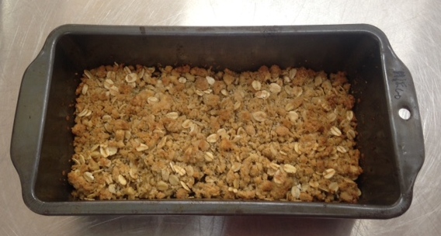
⅓ cup water
1 Tbs sugar
½ tsp lemon juice
¼ tsp cinnamon
2 Tbs sultanas

Crumble Mix
75g plain flour
50g margarine
50g brown sugar
¼ cup rolled oats
¼ cup coconut

Method
- Preheat oven to 190°C. Grease a loaf tin.
- Peel, core and dice apples.
- Put all apple mix ingredients into a small saucepan and mix well.
- Cover and cook over medium heat for 8 minutes.
- Sift flour in a medium mixing bowl.
- Add margarine and rub into flour using fingertips until mixture resembles breadcrumbs.
- Add brown sugar, coconut and rolled oats. Mix well.
- Drain cooked apple mixture and spoon into a baking dish.
- Scatter the crumble mixture evenly over the apples mixtures.
- Bake for 15 - 20 minutes or until golden.
- Serve with ice-cream.

Learning Intention: To learn how to stew fruit.
- Describe what stewing apples involves.
- What other fruit could be used in place of apples?
- What was your extra duty today? Explain in detail, what was involved in completing it.

