Meringue Cookies

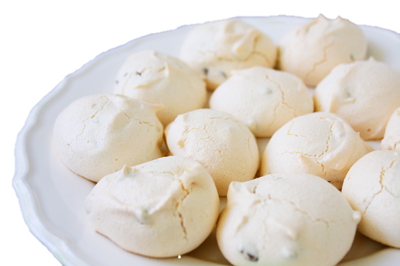
Ingredients (per pair)

2 egg whites
1/8 tsp salt
1/8 tsp cream of tartar
1 tsp vanilla essence
¾ cup sugar

Food colourings (optional)

Method

- Preheat oven to 150$℃$.
- Beat egg whites in large bowl with electric mixer on medium speed until frothy. Add salt, cream of tartar; beat until soft peaks form.
- Increase speed to medium-high. Add sugar, 1 tablespoon at a time, beating until sugar is dissolved and stiff peaks form.
- Beat in vanilla essence.
- Place meringue in separate small bowls. Add drops of food colouring of your choice and mix well gently.
- Drop small teaspoonfuls on a lined baking tray.
- Bake for 25 - 30 minutes. Leave the oven door ajar and allow meringue cookies to cool in the oven.

Learning Intention
To know the difference between frothy, soft peaks & stiff peaks when beating eggs.
- Why is cream of tartar added to the egg whites when frothy?
- Why must the sugar be dissolved in the egg?
- Why are the cookies left in the oven with the door open to cool?

