Chicken with Black Bean Sauce

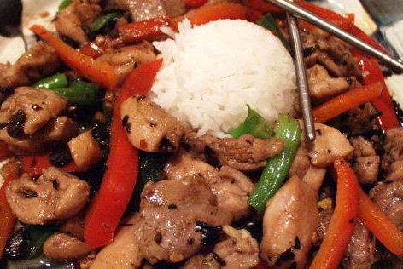
Ingredients (Per Pair)

200g Chicken breast fillet
½ onion
¼ red capsicum
¼ green capsicum
Pinch of salt
1 Tbs oil
Spring onion curls to garnish

Sauce: ¾ Tbs black bean sauce
½ tsp minced garlic
1 tsp sugar
1 tsp oil
1 tsp light soya sauce
¼ tsp cornflour
2 tsp water

Method
- Combine sauce ingredients and set aside.
- Make spring onion curls.
- Slice onion and capsicums. Slice chicken thinly.
- Heat 1 Tbs oil in large frypan. Sauté onion until soft. Add chicken and pinch of salt, stir-fry chicken for about 2 minutes or until cooked.
- Add the sauce mixture and the capsicums, stir-fry another two minutes.
- Dish up with rice. Garnish with spring onion curls.
- Serve hot.
Learning Intention
To know why marinating is used
- How could you use the words infuse and marinate in the one sentence? Research if needed.
- Why is important to make the spring onion curls fine?
- Name at least 3 other Chinese dishes that you enjoy eating?

