Spaghetti Bolognaise

Ingredients (Per Pair)
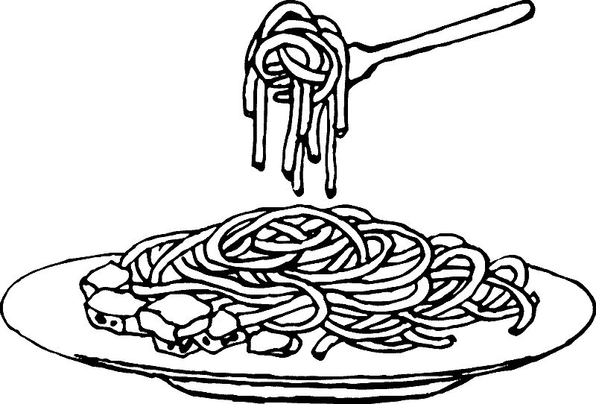
120g spaghetti
120g minced beef
¼ onion, chopped
1 tsp crushed garlic
200g (1/2 can) diced tomato
3 Tbs tomato condensed soup
1 Tbs oil
Pinch of salt and Pepper
1/3 cup grated Tasty Cheese

Method

- Half fill a large saucepan with hot water and ¼ tsp salt and bring to the boil.
- Add spaghetti to boiling water and cook for about 15 minutes or until al dente.
- Fry onion and garlic in oil until tender.
- Add meat, break up with spatula spoon and fry gently.
- Add diced tomato, tomato puree, salt and pepper. Simmer meat sauce over a low heat for about 5 minutes.
- Drain spaghetti and serve.
- Pour sauce over spaghetti, sprinkle with cheese.
- Serve hot.
Learning Intention
To learn when pasta is cooked al dente

- What does al dente mean?
- Think about the spaghetti bolognaise that is made in your house. How is it different to what we’ve made today?
- List all of the equipment that you’ve used today.

