Anzac Biscuits

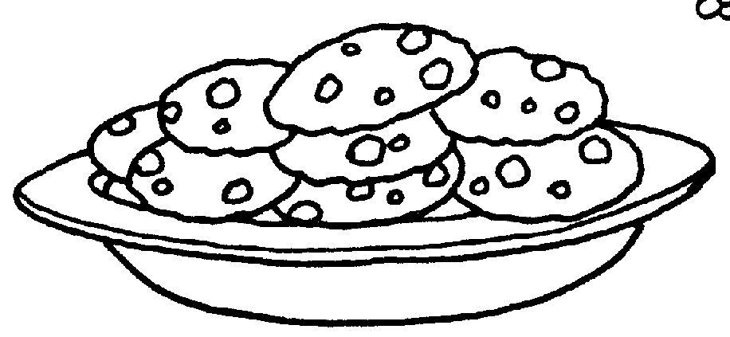
Ingredients (Per Pair)
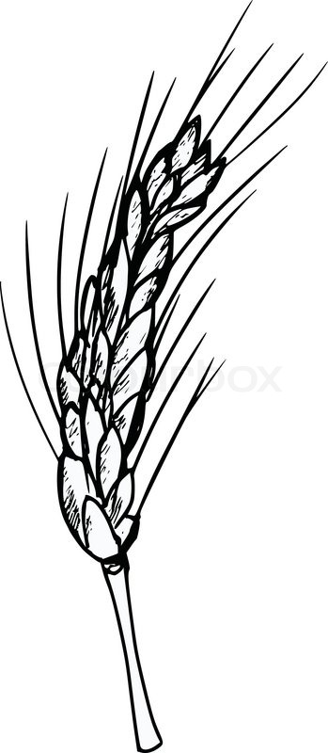
1 cup rolled oats
¾ cup plain flour, sifted
1 cup sugar
¾ cup desiccated coconut
½ cup margarine or butter
2 Tbs golden syrup
½ tsp bicarbonate of soda
1 Tbs boiling water

Method
- Preheat oven to 150$℃$.
- Combine oats, sifted flour, sugar and coconut.
- Combine margarine and golden syrup in a small saucepan and stir over gentle heat until melted.
- Mix soda with boiling water, add to melted margarine mixture.
- Stir the liquid into the dry ingredients and mix well.
- Take teaspoonfuls of mixture and place on a lightly greased tray; allow room to spread.
- Bake in a slow oven for 20 minutes.
- Loosen while warm, then cool on the tray.

Learning Intention
To know the difference between wet and dry ingredients
- Divide the ingredients into 2 columns. Wet & Dry.
- What is the difference between the wet & dry ingredients?
- Explain what happened when you added the bicarb soda. Why do you think it did this?

