Submarine Meat Roll

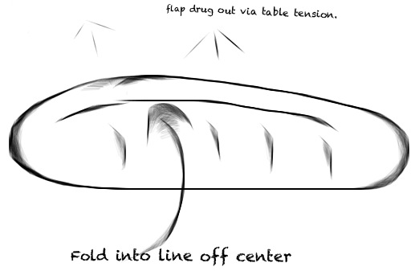
Ingredients (Per Pair)
CUT

¼ Onion, chopped
¼ tsp crushed garlic
2 tsp oil
100g Minced beef
½ tsp chicken powder
1 tsp cornflour
¼ cup water
1 tsp parsley, chopped
2 Tbs cheese
2 Bread Rolls

Method

- Preheat oven 180$℃$.
- Heat oil and fry chopped onion and garlic until soft.
- Add minced beef and fry until golden brown.
- Add chicken stock powder to the pan.
- Stir in cornflour and cook gently for 1 minute.
- Add water and bring to the boil, cook for 1 minute, stirring all the time.
- Add the chopped parsley.
- Gently split the roll horizontally across the middle, leaving the ends intact to form a pocket.
- Remove some of the bread.
- Spoon the meat mixture into the bread roll, filling it.
- Sprinkle cheese on top.
- Wrap the roll in foil and bake for 10 minutes.

Learning Intention
To learn how to make savoury mince that can be used in many ways.
- Why is it important to not cut the roll right through?
- What are some other ways you could use this meat recipe?
- Identify something that you were proud of today and also something that you feel you could improve on.

