Chocolate Self-Saucing Pudding

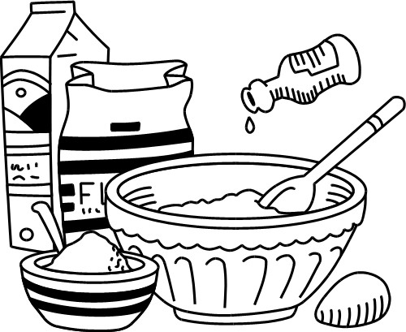
Ingredients (Per Pair)
1 Tbs margarine
¼ cup sugar
½ cup SR flour, sifted
1 Tbs milk
1 egg
1 Tbs cocoa
1 tsp vanilla

Sauce
¼ cup sugar
2 tsp cocoa
½ cup hot water

Method
- Preheat oven to 180$℃$ and grease a medium, deep baking dish.
- Batter: Cream margarine and sugar in a mixing bowl.
- Add vanilla and egg and mix well.
- Stir in sifted flour and cocoa alternately with the milk.
- Place batter evenly in the greased baking dish.
- Mix extra sugar and cocoa in a small bowl to remove lumps.
- Sprinkle the extra sugar and cocoa over the top of batter.
- Pour the hot water in gently over the back of a wooden spoon.
- Bake pudding for 15-20 minutes.
- Serve with ice-cream.

Learning Intention
Today we will learn how to use cocoa to make a delicious quick dessert
- What are the wet ingredients in this recipe?
- Identify 4 other dishes that have cocoa in them.
- Thinking about your time management, write a short paragraph about what went well and what you and your partner could improve on.

