Beef Burger

Ingredients (Per Pair)

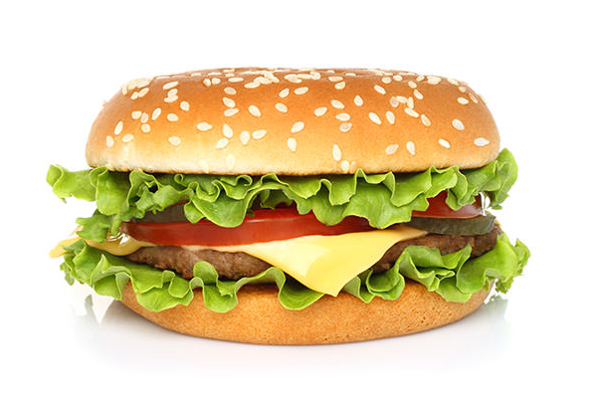
200g beef mince
2 Tbs breadcrumbs
½ onion, grated
½ beaten egg
1 sprig continental parsley
1 tsp minced garlic
1 tsp Worcestershire sauce
½ tsp Tabasco sauce
Salt and pepper, to taste
1 Tbs oil
2 hamburger buns
2 Tbs margarine
2 slices cheese
2 slices tomato
2 lettuce leaves
Mustard and/or tomato sauce to serve

Method
- Place the beef mince, breadcrumbs, egg, onion, garlic, Worcestershire sauce and Tabasco sauce in large bowl. Season with salt and pepper. Mix until evenly combined.
- Divide the mixture into 2 equal portions. Shape each portion with your hands into a patty.
- Heat oil frying pan over medium-low heat and cook patties for about 4 minutes on each side or until browned and cooked through.
- Wipe the pan clean.
- Separate hamburger buns and spread margarine.
- Toast hamburger buns in frypan with the margarine side down.
- Spread the bottom halves of the toasted hamburger buns with the mustard. Top with the lettuce, sliced tomato, patties and dollop with tomato sauce. Cover with the hamburger bun tops.
Learning Intention
To know how to make a beef patty extra tasty
- What ingredients contributed to the tastiness of the beef patty?
- What ingredient assisted with binding the beef patty together?
- If you could change this recipe, what would you differently. Why?

