Boiled Chocolate Cup Cake

Ingredients (Per Pair)
Make 12

½ cup margarine
2 Tbs cocoa powder
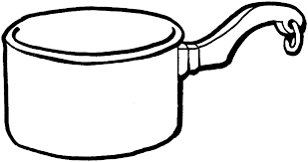
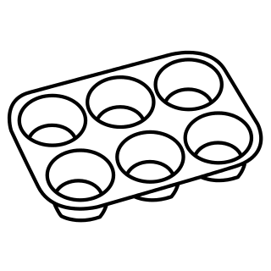
½ tsp bicarbonate of soda
1¼ cup sugar
1 cup water

1½ cup SR flour
2 eggs, beaten

Method
- Preheat oven to 200$℃$.
- Line muffin tray with patty pans.
- Place the first 5 ingredients into a large saucepan and bring to the boil. Remove mixture from heat and cool slightly.
- Sift flour. Add sifted flour and egg alternately. Stir well.
- Spoon mixture into prepared muffin tray.
- Bake for about 15 minutes until springy.
- Dust with icing sugar.

Learning Intention
To learn how to make a cake by boiling the mixture

- How much is ½ cup of margarine in grams?
- How could you cool the mixture more quickly?
- Why is it important to cool the mixture before adding the eggs?

