Melting Moments

Ingredients (Per Pair)
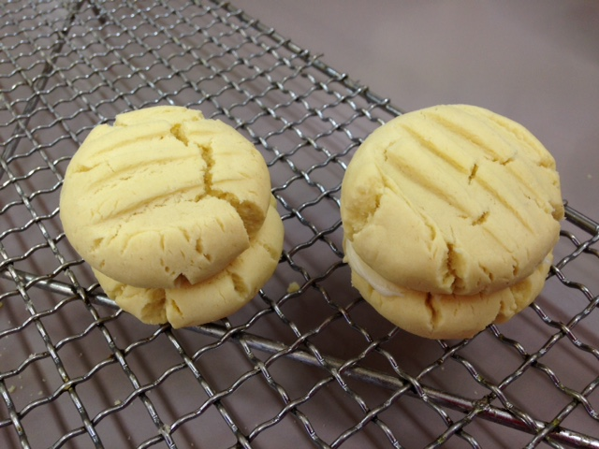
Biscuits:
½ cup margarine
¼ cup icing sugar
¾ cup SR flour
½ cup cornflour

Icing:
1 cup icing sugar
1 Tbs margarine
¼ tsp vanilla essence
2 tsp water

Method
- Preheat oven to 160$℃$. Grease oven tray.
- Cream margarine and sugar using a wooden spoon.
- Sift SR flour and cornflour together.
- Add combined and sifted flours to creamed mixture. Mix thoroughly.
- Make mixture into small balls, place on a lined tray and allow room to spread. Press down gently with a fork.
- Bake for 15-20 minutes or until just starting to colour.
- Remove from oven and let set on tray for a few minutes.
- Place on wire rack to cool.
- To make icing mixture, sift icing sugar. Then cream margarine, adding icing sugar gradually. Add vanilla essence and mix thoroughly. Water may be added if softer icing is needed.
- Sandwich biscuits together with icing mixture.

Learning Intention:
To learn the importance of making small Melting Moments.
- Why do we make small biscuits for our melting moments?
- We use a plain biscuit with vanilla icing. What other ideas can you come with?
- Why do we use a slow oven to cook our biscuits?

