Tzatziki Sauce

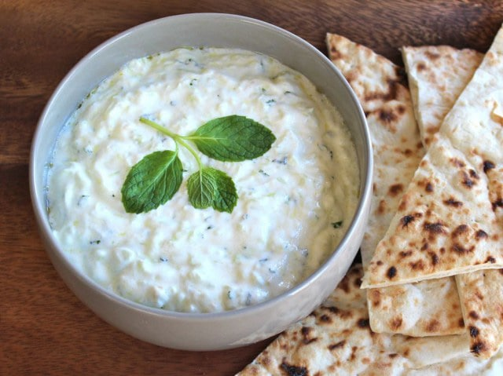
Ingredients (Per Pair)

½ cucumber
100g natural yoghurt
1 tsp dried mint
1 tsp lemon juice
½ tsp minced garlic
1 sprig fresh mint, chopped
salt and black pepper to taste

Method

- No need to peel or seed the cucumber, grate on the large holes of your grater. Lightly squeeze the grated cucumber between your palms over the sink to remove excess moisture. Transfer the squeezed cucumber to a serving bowl.
- Add the yoghurt, herbs, lemon juice, garlic, salt and pepper to the cucumber bowl, stir to blend. Let the mixture rest for 5 minutes to allow the flavour to meld/infuse.
- Serve tzatziki immediately or chill for later. Consume within 4 days.

Learning Intention
To know how to grate and prepare cucumber when making a dip.
- Why are the largest holes used on the grater?
- Why is the excess moisture squeezed from the cucumber?
- What do the words meld or infused mean?

