Brandy Snaps
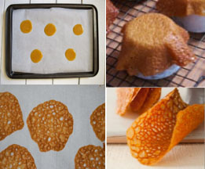
Ingredients (Per Pair)
2 Tbs golden syrup
2 Tbs Margarine
2 Tbs sugar
2 Tbs plain flour
¼ tsp ground ginger
¼ tsp lemon juice
Method
- Preheat oven to 180$℃$.
- Put the flour and ginger in a small bowl.
- Put margarine, sugar and golden syrup in a saucepan.
- Heat gently until the margarine and sugar have melted. Remove from heat.
- Add the flour and ginger to the melted syrup. Stir until the mixture is thoroughly combined.
- Add lemon juice and stir well.
- Use a measuring tablespoon to dollop the mixture onto the lined baking tray.
- Space them well apart as they will spread.
- Bake for about 10 minutes till set, golden brown and lacy in appearance.
- Leave for a minute before shaping.
- Lift brandy snaps carefully from tray and drape warm brandy snaps over a rolling pin until cool and firm.
- Serve brandy snaps with ice-cream.
Learning Intention
Today we will learn how to tell when brandy snaps are cooked enough by time and colour.
- What will happen if you remove your snaps too soon?
- What is meant by the term, lacy?
- Using your creative skills, explain a delicious dessert that you could use this recipe for.

