Butter Chicken

Butter chicken (Per Pair)

200g Chicken thigh fillets, diced
1 tomato, diced
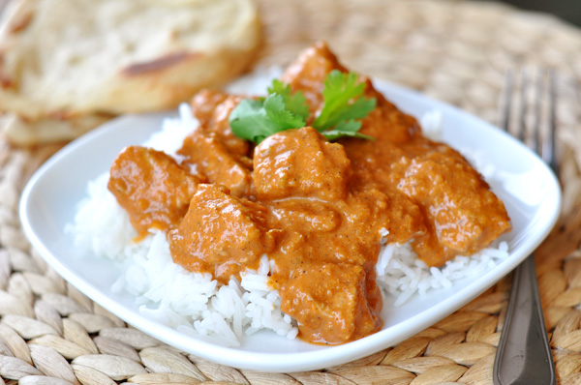
150 ml condensed tomato soup
1 tsp ground cumin
1 tsp garam masala
¼ tsp chilli powder
1 tsp ground coriander
1 tsp crushed ginger
¼ cup cream
¼ cup Greek style yoghurt
½ cup spinach
2 tsp oils
${2cm}^{3}$ butter

Method
- Gently pan fry diced chicken with oil and butter until golden brown.
- Add diced tomato, ginger, cumin, coriander, garam masala, and chilli powder and cook for a further 3-5 minutes.
- Add Soup, and ½ cup cold water. Stir well and bring to boil, then reduce heat and simmer for 10 minutes or until thickened.
- Stir through cream. Add spinach and yoghurt and then stir until spinach has wilted.
- Serve with steamed rice and top with parsley leaves.

Learning Intention
To have a basic understanding of Indian spices.
- What spices are mixed to make garam masala?
- Why do we add cream and yoghurt to the dish?
- What do we use in this dish that is different to a traditional version?

